**R-FUNCTIONS HOMEWORK**

Nanjesh Ramesh

CIN: 307402152

1. **Screenshot of the R-script:**

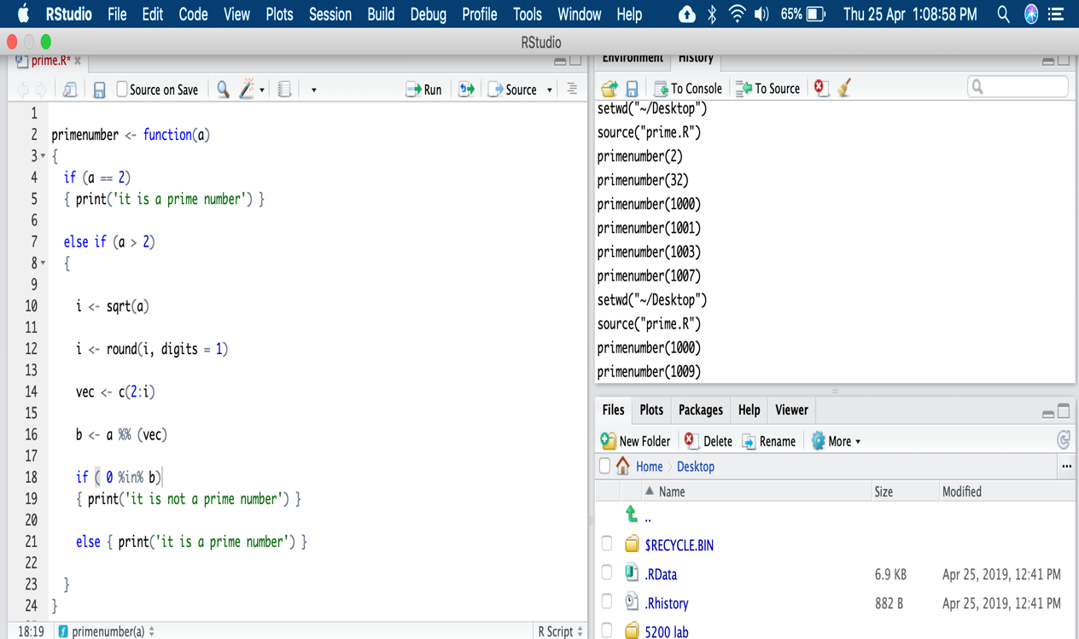

1. **Screenshot of the result/function execution:**

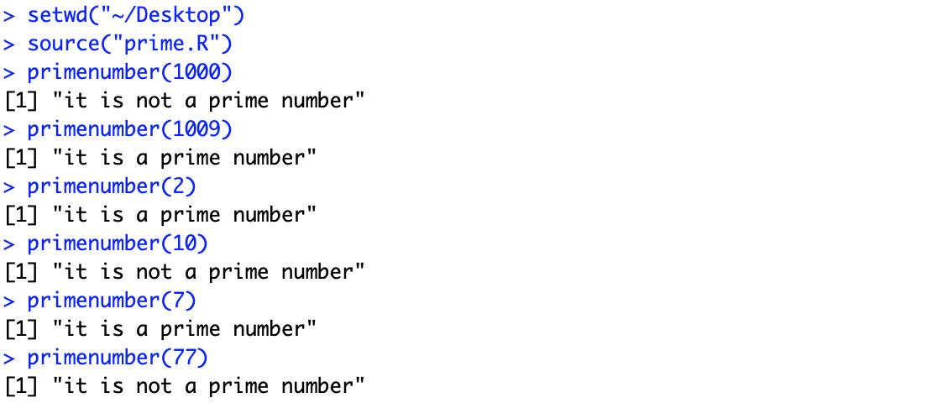



1. **Code to check if a number is prime or not a prime:**

primenumber <- function(a)

{

if (a == 2)

{ print('it is a prime number') }

else if (a > 2)

{

i <- sqrt(a)

i <- round(i, digits = 1)

vec <- c(2:i)

b <- a %% (vec)

if ( 0 %in% b)

{ print('it is not a prime number') }

else { print('it is a prime number') }

}

}